NMAP HOST DISCOVERY AND SCANNING
Practical / Laboratory Record
AIM
To perform host discovery and basic network scanning using Nmap on the target IP address 192.168.1.1, and to understand the use of different Nmap host-discovery options such as -PR, -n, and -Pn.
REQUIREMENTS
- Kali Linux / Linux terminal
- Nmap (Network Mapper)
- A system or network interface with access to the target network
- Target IP address: 192.168.1.1
PROCEDURE
- Open the terminal in Kali Linux or another system where Nmap is installed.
- Verify that Nmap is available by running the Nmap command or checking its version.
- Specify the target IP address as 192.168.1.1.
- Use Nmap host-discovery options to determine whether the target host is online.
- Use the command `nmap -PR 192.168.1.1` to perform ARP-based host discovery on a local Ethernet network.
- Use the command `nmap -n 192.168.1.1` to scan the target without DNS name resolution.
- If the host does not respond to normal host-discovery probes, use `nmap -Pn 192.168.1.1`. This treats the host as online and proceeds with the port scan.
- Observe the Nmap output and note whether the host is detected as up and what ports/services are reported.
COMMANDS USED
Purpose | Nmap Command
ARP host discovery | nmap -PR 192.168.1.1
Disable DNS resolution | nmap -n 192.168.1.1
Skip host discovery | nmap -Pn 192.168.1.1
NOTE
In the first screenshot, some commands appear with the option and IP address joined together (for example, `-Pn192.168.1.1`). The correct syntax requires a space: `nmap -Pn 192.168.1.1`. Similarly, use `nmap -sn 192.168.1.1` for a ping scan. The usage message shown in the screenshot is consistent with an invalid target/option format.
SCREENSHOTS / OUTPUT
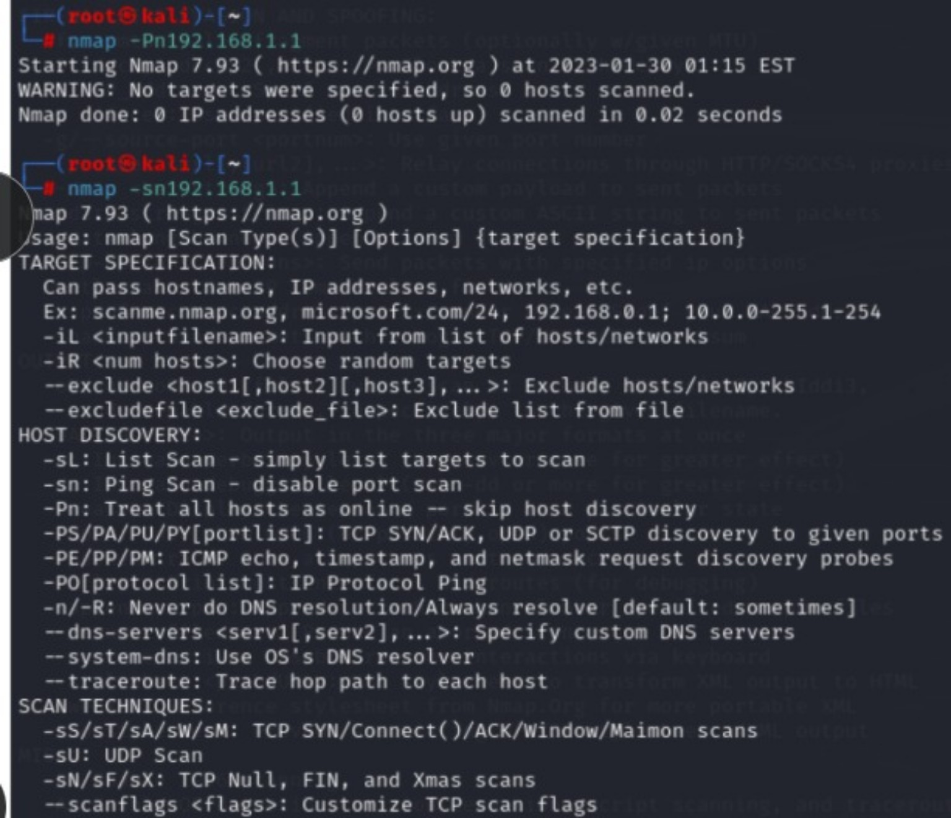
Figure 1: Nmap command usage and host-discovery options.
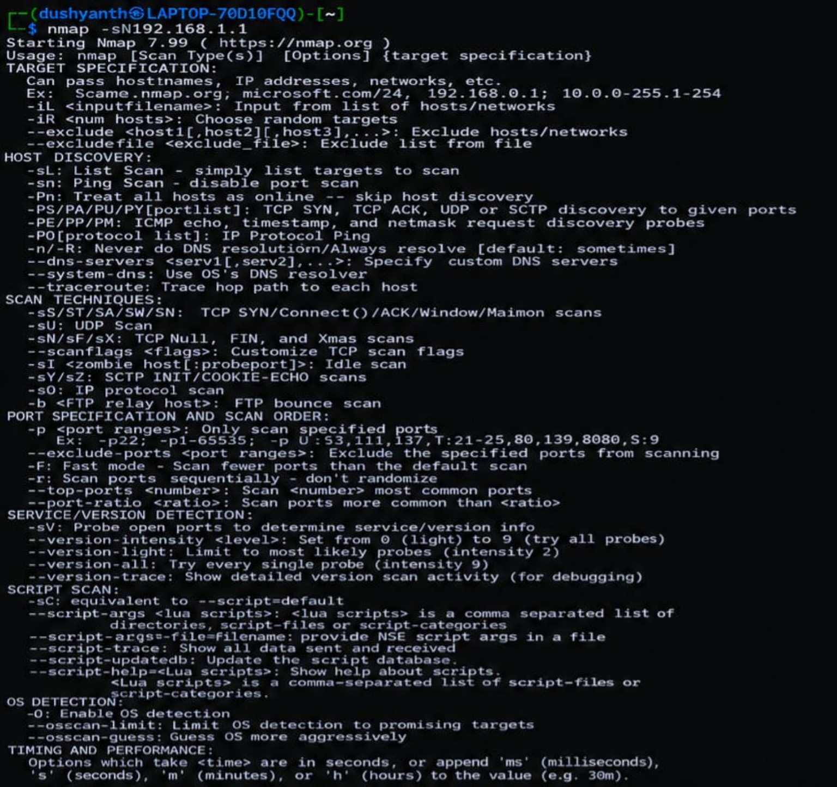
Figure 2: Nmap scan options and scan techniques.
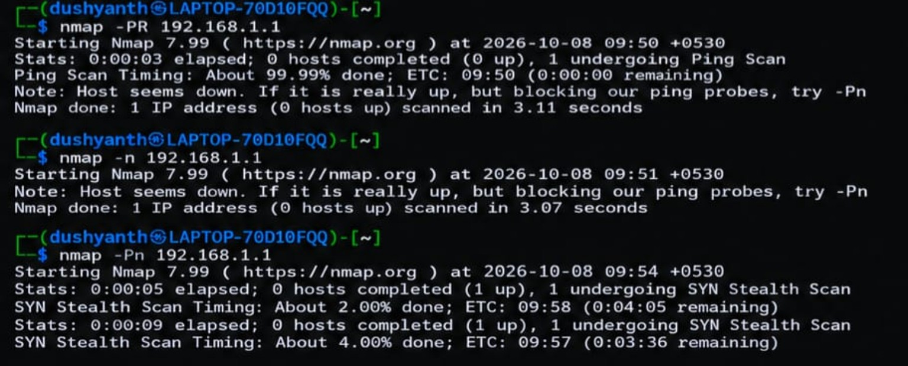
Figure 3: Nmap host discovery and -Pn scan output for 192.168.1.1.
RESULT
Nmap host-discovery and scanning commands were executed for 192.168.1.1. The screenshots demonstrate Nmap's available scan techniques and the behavior when the target does not respond to normal discovery probes. The -Pn option allows Nmap to proceed with scanning by treating the target as online.
SAFETY / ETHICAL NOTE
Perform Nmap scans only on systems and networks that you own or have explicit permission to test.

